Mini Project # 3

Name: VEDANT KUMAR

ID: vxk180003

Name of group members: -

Contribution of each group member: -N/A-

1. Mean Squared Error will be carried out by the simulating Uniform Distribution(n, 0, theta) over N times to get the random values that will make the sample set. As per the given theta and n values, a total of 24 pairs will be formed.

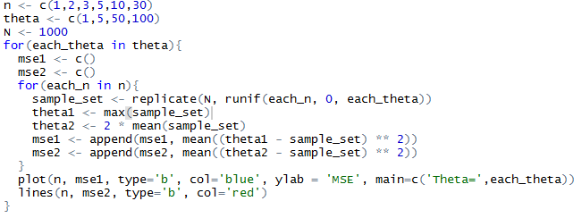

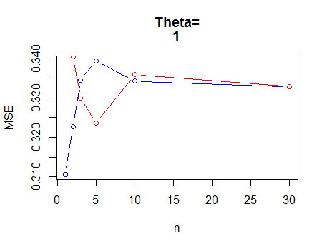

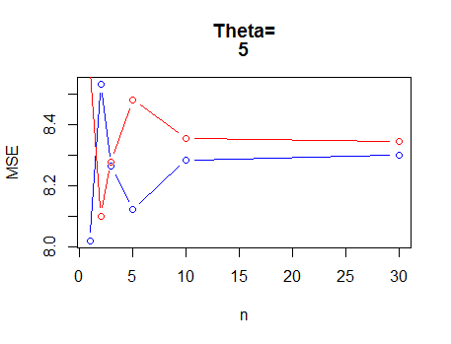

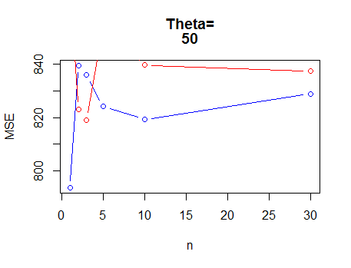

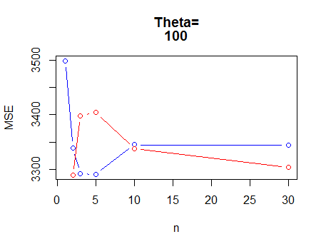

Graphically, the conclusion can be drawn when the sample size is very small n<10 the estimators show a lot of variance between them. The THETA-1 estimator works very well on these cases. As the sample size increases both estimators come closer and give approx. same value. So, THETA-1 can be preferred over entire sample space.

1. C. D.

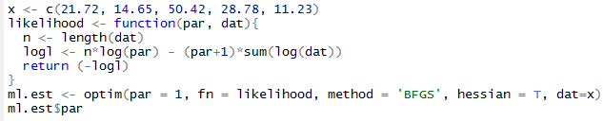



Yes, the answer found using R matches with the numerical estimate of the density function.

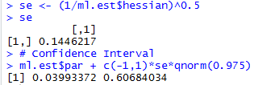

Yes, the lower and upper limit values hold 95% of the data in between them. Out of 100 trials, 5 of them may fall out of these limits.